DEVOPS WEEKLY TASK -1: GIT BASICS
- Step -1: Install VS code through VS CODE
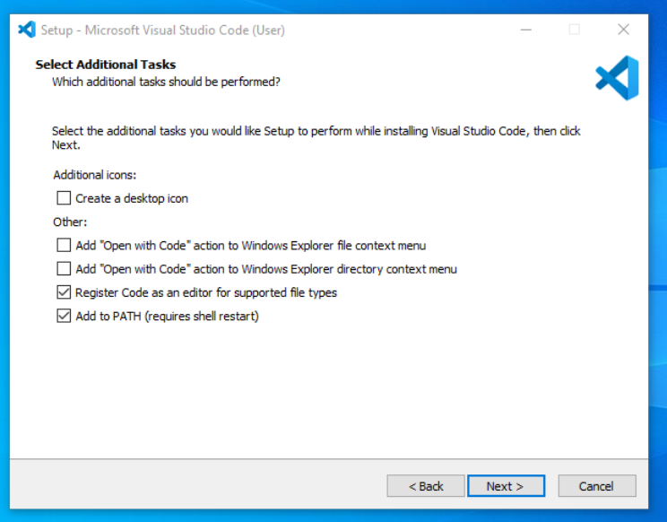
- Step -2: Install Git through GIT
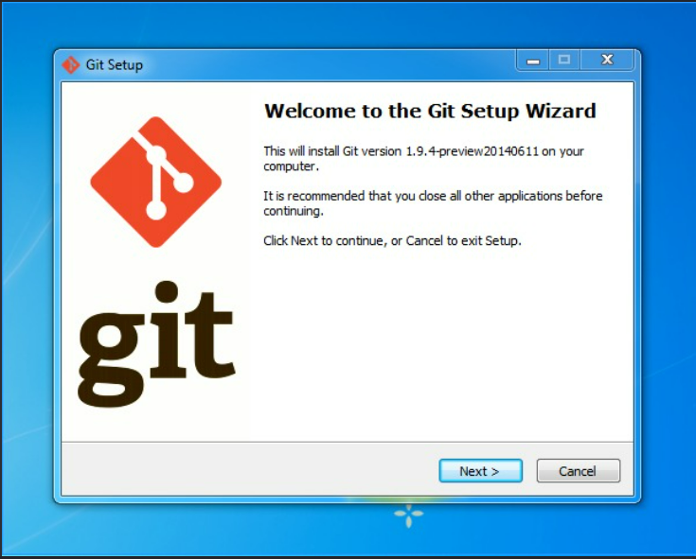
- Step-3: Configure your git as follows:

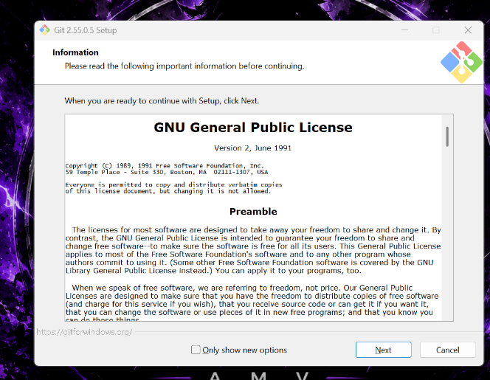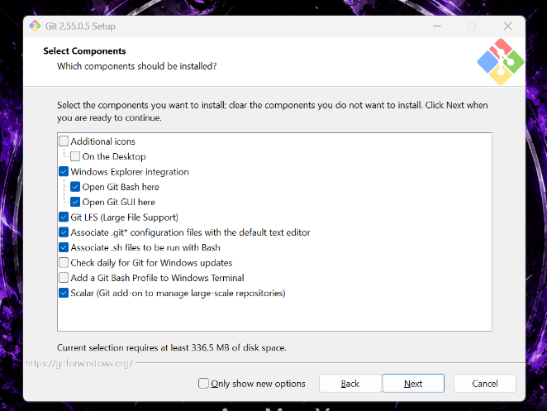

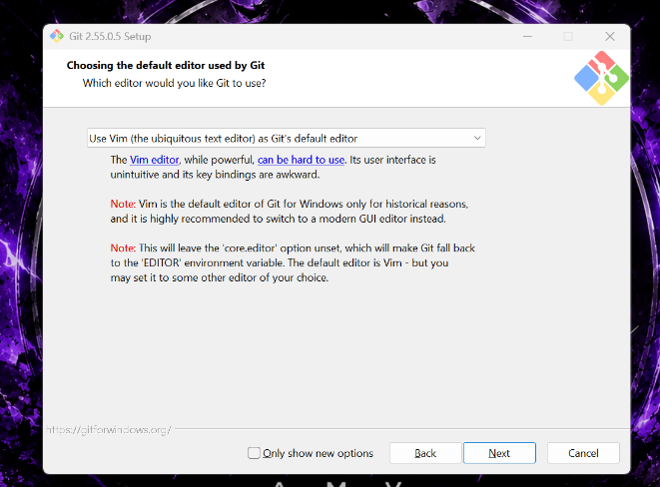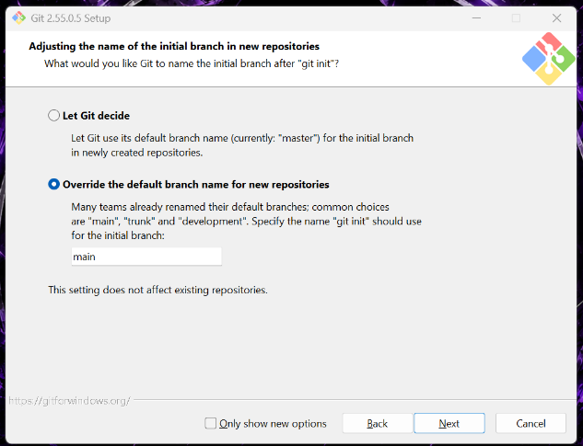

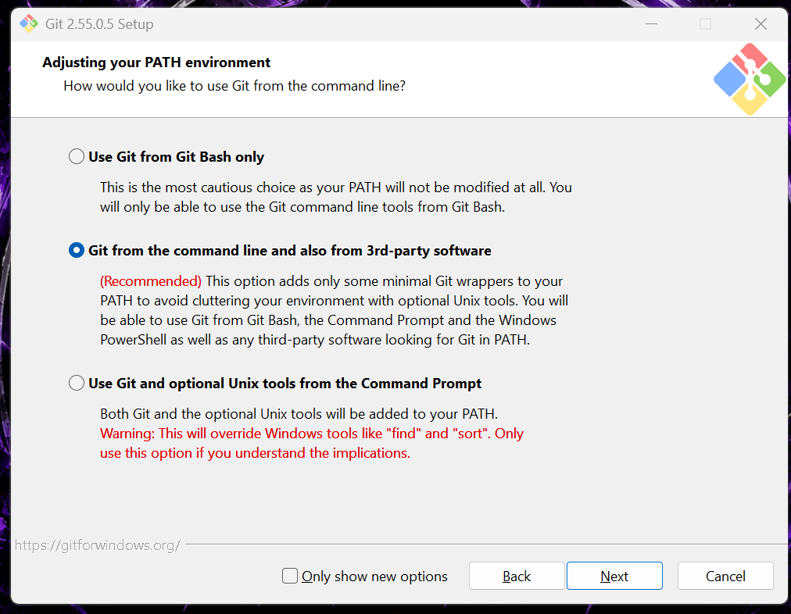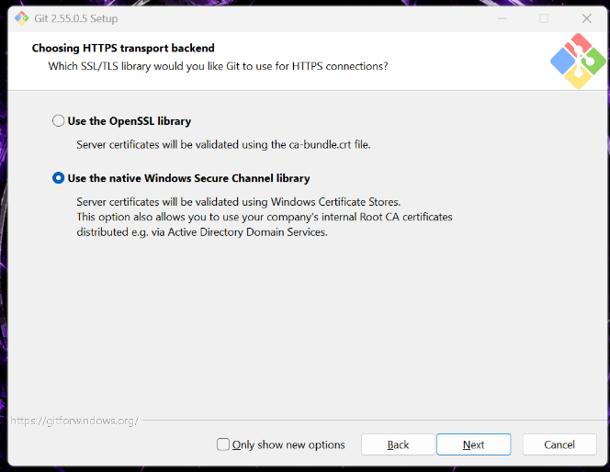

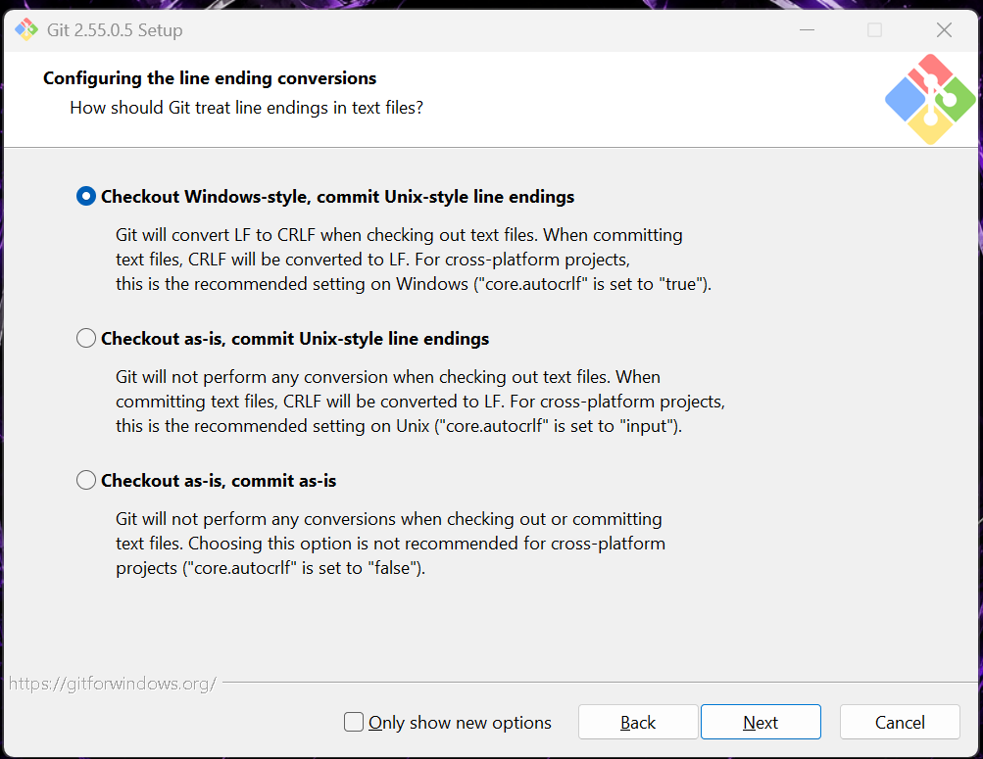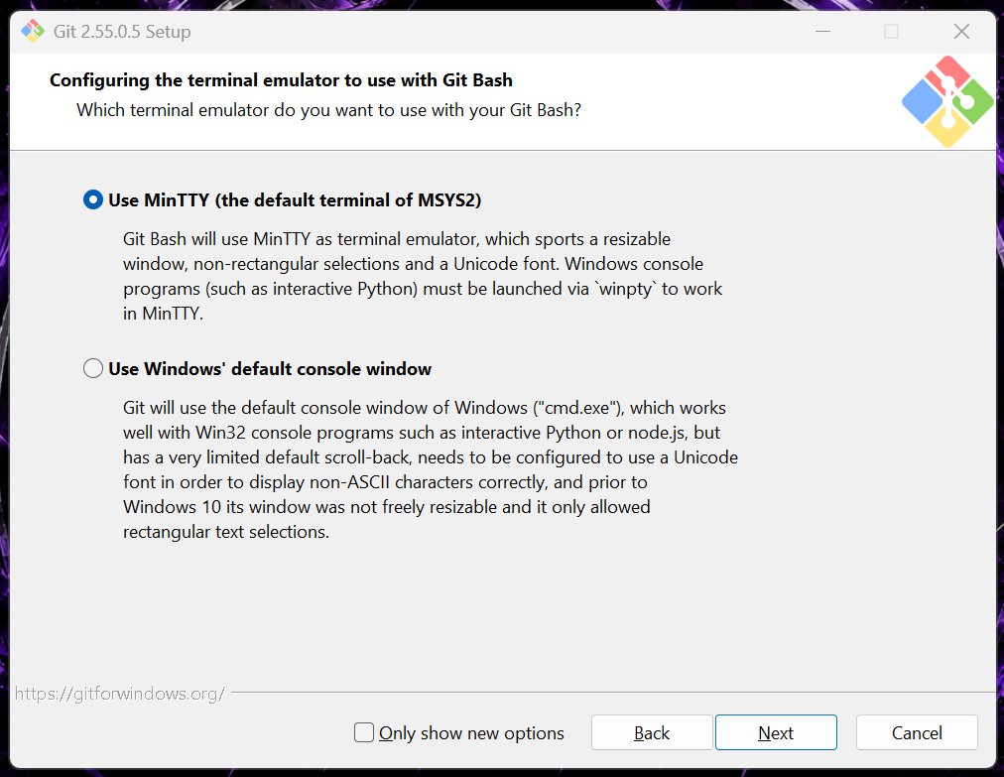

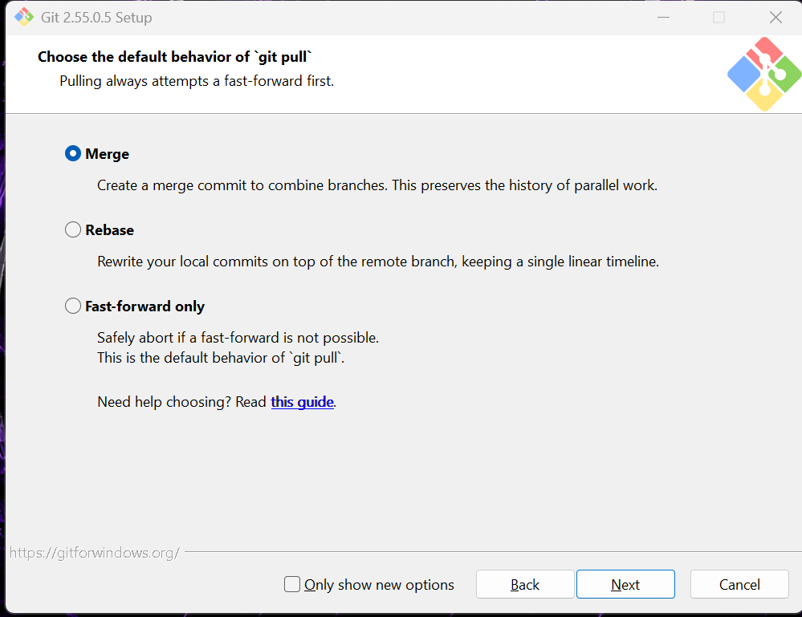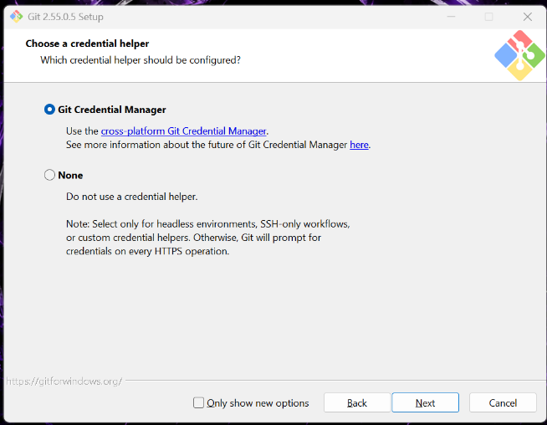

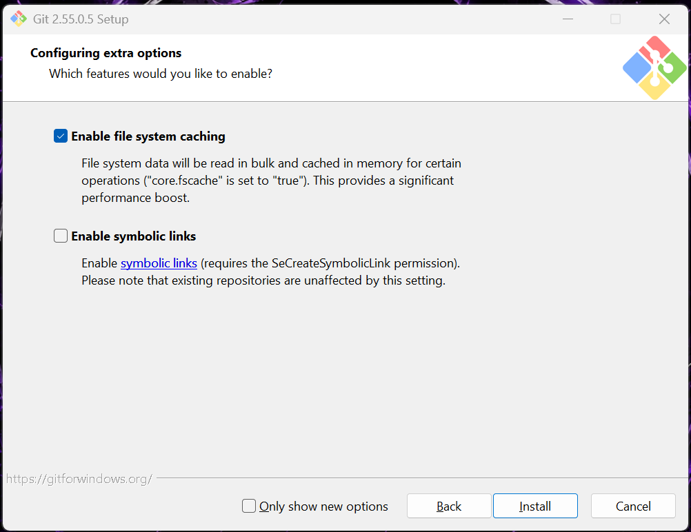

- Step – 4: Create a new Directory for the DevOps Weekly Tasks
- Step – 5: Create a file named “Hello-World.txt” for this week’s task.
- Step – 6: Added contents inside the file and perform the following git actions in the terminal of the Vs Code (shortcut for going into the terminal in VsCode: Ctrl + `).
- Git init – initializes an empty git local repository in that directory.
- Git add filename – Moves the changes from the file to the staging area.
- Git status – gives the status of files in the local repository.
- Git commit -m “Message” – Commit the changes made to the file in the local repository of the directory.
- Git diff – Displays the changes made from the last saved commit.
- Git reset – Undo changes, unstages files, or discard work from the local repository
  - Git reset --soft: changes only the commit history, not the staging area or the file.
  - Git reset --mixed: changes the commit history and unstages the changes made to the file, but does not change the file itself.
  - Git reset --hard: Changes the commit history, unstages the changes, and change the file to the pointed commit changes and remove the changes made after the pointed commit.
- Git log – Displays the history of the commits made in the local repository along with the commit messages and which files are included in that particular commit.
  - Git log --online: displays the commit history with only the commit ID and the commit message.
  - Git log --online --decorate --graph : Displays the commit history along with a graph which represents the branch and merge history to the log output
THE FOLLOWING PICTURE WILL DEMONSTRATE THE USE OF THE ABOVE MENTIONED GIT COMMANDS WITH A TEXT FILE AS AN EXAMPLE:
